Lab 01 Write Up

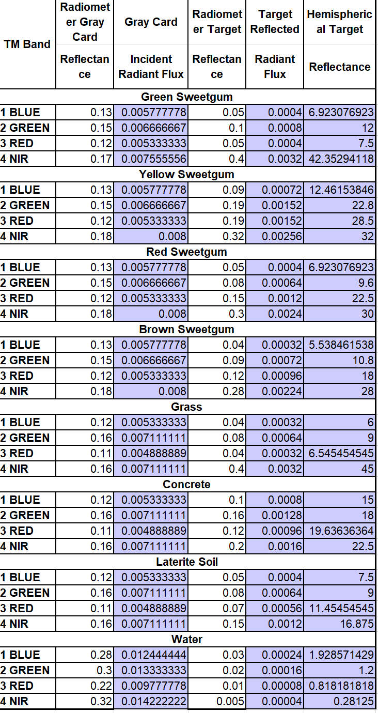

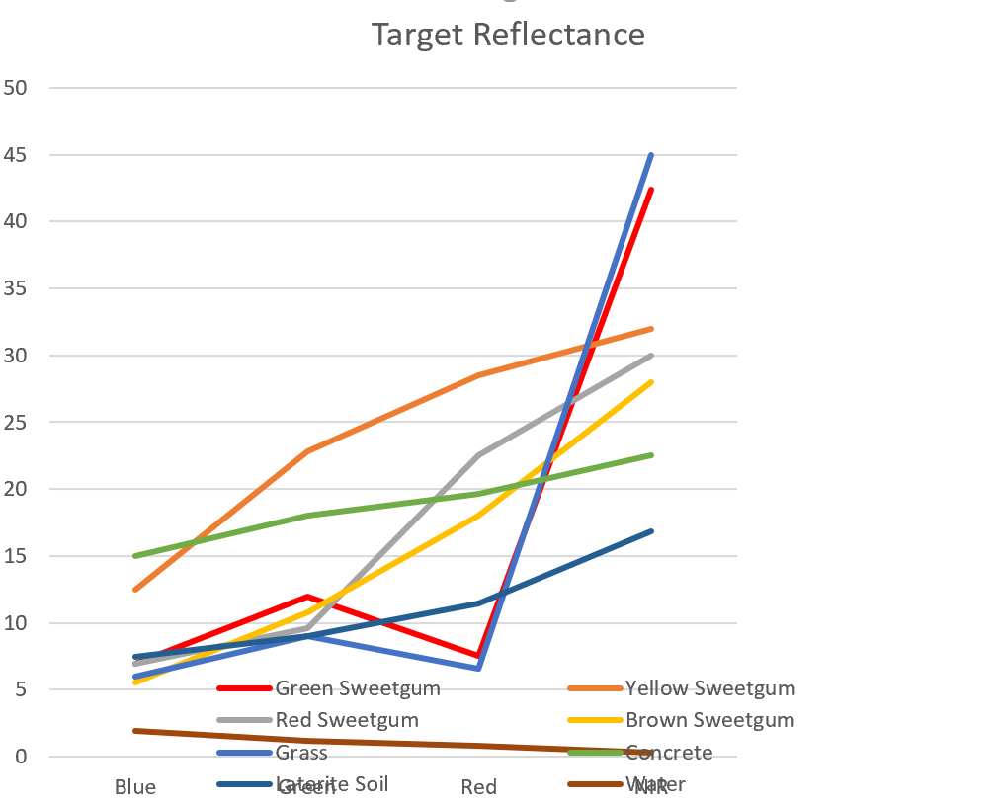

1. Determine which of the bands available to you is best for discriminating between the following target classes:

A. Green Sweetgum and Red Sweetgum

The Red band is the best for discriminating between the Green and the Red Sweetgum.

B. Yellow Sweetgum and Green Sweetgum

The Red band is the best for discriminating between the Yellow and the Green Sweetgum.

C. Brown Sweetgum and Red Sweetgum

The Red bank is the best for discriminating between the Brown and the Red Sweetgum.

D. Brown Sweetgum and Grass

The NIR band is the best for discriminating between the Brown Sweetgum and the Grass.

E. Grass and Soil

The NIR band is the best for discriminating between the Grass and the Soil.

F. Concrete and Soil

The Green band is the best for discriminating between the Concrete and the Soil.

G. Water and Soil

The NIR band is the best for discriminating between the Water and the Soil.

2. In which of the four bands is Yellow Sweetgum the lightest tone (highest reflectance)? The darkest tone (lowest reflectance)?

The Yellow Sweetgum is the lightest in the NIR band, and the darkest in the Blue band.

3. If you were to choose only two spectral bands to discriminate between all targets, which bands would you select and why?

I would choose the Red band and the NIR band since they help delineate between different targets with the most clarity.

4. Why does the human visual system (i.e., our eyes, etc.) perceive healthy vegetation as green in color? What is the standard spectral reflectance curve for almost all healthy green vegetation? (Give a verbal description and graphically draw an example vegetation spectral reflectance curve.)

We perceive healthy plants as green due to the chlorophyll absorbing the blue and red wavelengths and reflecting the green wavelengths. Spectral reflectance curves graph the percent of reflectance of objects being measured as a function of the wavelengths. A standard spectral reflectance curve for most healthy vegetation looks like this:

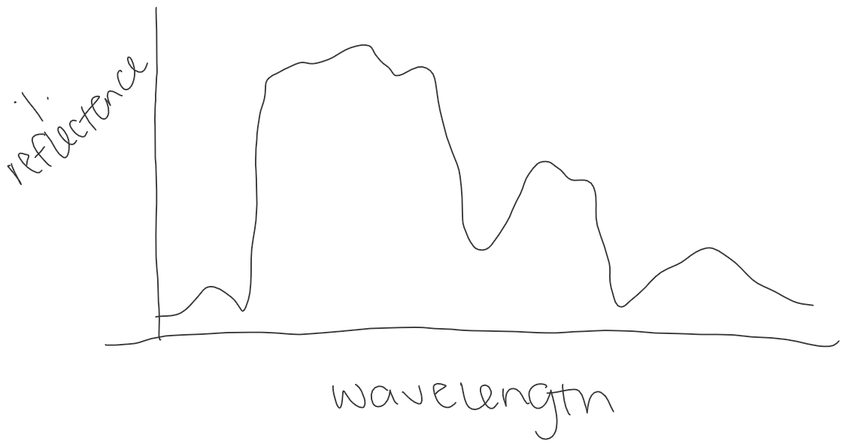

5. How do you think the presence of moisture in soil will affect its reflectance?

I would assume that the more moisture, the less reflectance since water itself has a relatively low reflectance.

6. What are some of the factors that affect the reflective nature of water?

The relative smoothness/turbidness of the water would affect the reflective nature, as well as the salinity, and other concentrations of substances dissolved within the water.

7. Why is it important to investigate the nature of spectral reflectance curves from targets prior to planning a remote sensing project?

Understanding the nature of the spectral reflectance curves of the relative targets would inform the results the scientist could expect from the study. Some studies are targeting specific outcomes, so knowing the type of outcome to expect from relative reflectance would be significant. This would help the scientist use the correct data and execute the right remote sensing project.